WEEK 7

Mandatory Hands-On

**REACT**

**Create a React Application named “cricketapp” with the following components**

* *Cricketapp* application is created in the directory Week7\ cricketapp using *npx create-react-app cricketapp.*

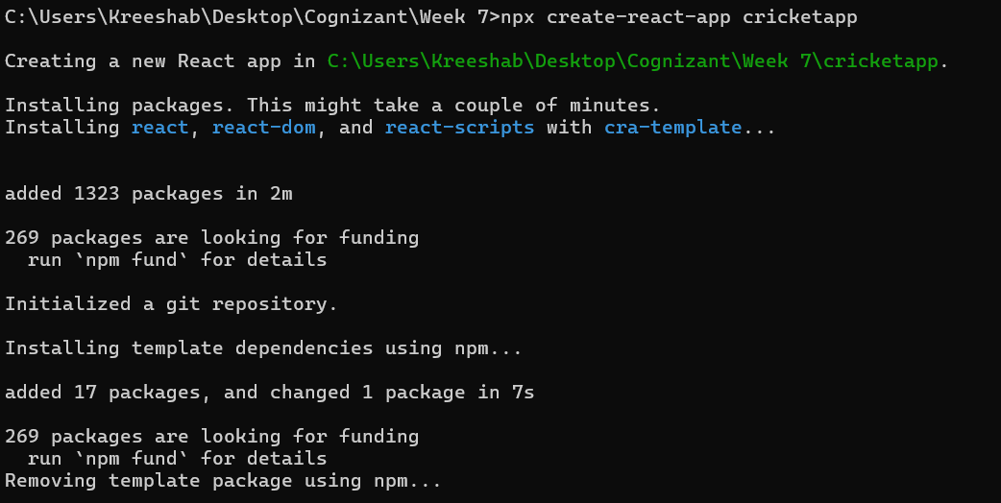

* Navigated to the React app and created required components inside src\ components.

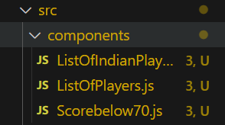

**ListOfIndianPlayers.js:**

import React from 'react';

export function OddPlayers([first, , third, , fifth]) {

  return (

    <div>

      <li>First: {first}</li>

      <li>Third: {third}</li>

      <li>Fifth: {fifth}</li>

    </div>

  );

};

export function EvenPlayers([, second, , fourth, , sixth]) {

  return (

    <div>

      <li>Second: {second}</li>

      <li>Fourth: {fourth}</li>

      <li>Sixth: {sixth}</li>

    </div>

  );

};

export const T20Players = ['first player', 'second player', 'third player'];

export const RanjiTrophyPlayers = ['fourth player', 'fifth player', 'sixth player'];

export const IndianPlayers = [...T20Players, ...RanjiTrophyPlayers];

export function ListOfIndianPlayers({ IndianPlayers }) {

  return (

    <div>

      {IndianPlayers.map((player, index) => (

        <h2 key={index}>{player}</h2>

      ))}

    </div>

  );

};

**ListOfPlayers.js:**

import React from 'react';

function ListOfPlayers({ players }) {

  return (

    <div>

      {players.map((player, index) => (

        <h2 key={index}>

          Mr. {player.name} <span>{player.score}</span>

        </h2>

      ))}

    </div>

  );

};

export default ListOfPlayers;

**Scorebelow70.js:**

import React from 'react';

function Scoredbelow70({ players }) {

  const filtered = players.filter((item) => item.score < 70);

  return (

    <div>

      {filtered.map((item, index) => (

        <h2 key={index}>

          Mr. {item.name} <span>{item.score}</span>

        </h2>

      ))}

    </div>

  );

};

export default Scoredbelow70;

**App.js:**

import React from 'react';

import './App.css';

import ListOfPlayers from './components/ListOfPlayers';

import Scoredbelow70 from './components/Scorebelow70';

import {

  ListOfIndianPlayers,

  OddPlayers,

  EvenPlayers,

  IndianPlayers

} from './components/ListOfIndianPlayers';

function App() {

  const flag = true;

  const players = [

    { name: 'Jack', score: 50 },

    { name: 'Michael', score: 70 },

    { name: 'John', score: 40 },

    { name: 'Ann', score: 61 },

    { name: 'Elisabeth', score: 61 },

    { name: 'Sachin', score: 95 },

    { name: 'Dhoni', score: 100 },

    { name: 'Virat', score: 84 },

    { name: 'Jadeja', score: 64 },

    { name: 'Raina', score: 75 },

    { name: 'Rohit', score: 80 }

  ];

  if (flag === true) {

    return (

      <div>

        <h1>List of Players</h1>

        <ListOfPlayers players={players} />

        <hr />

        <h1>List of Players having Scores Less than 70</h1>

        <Scoredbelow70 players={players} />

      </div>

    );

  } else {

    return (

      <div>

        <h1>Indian Team:</h1>

        <h2>Odd Players:</h2>

        {OddPlayers(IndianPlayers)}

        <hr />

        <h2>Even Players:</h2>

        {EvenPlayers(IndianPlayers)}

        <hr />

        <h2>All Indian Players (Merged):</h2>

        <ListOfIndianPlayers IndianPlayers={IndianPlayers} />

      </div>

    );

  }

}

export default App;

**Sample Output:**

When flag=== true

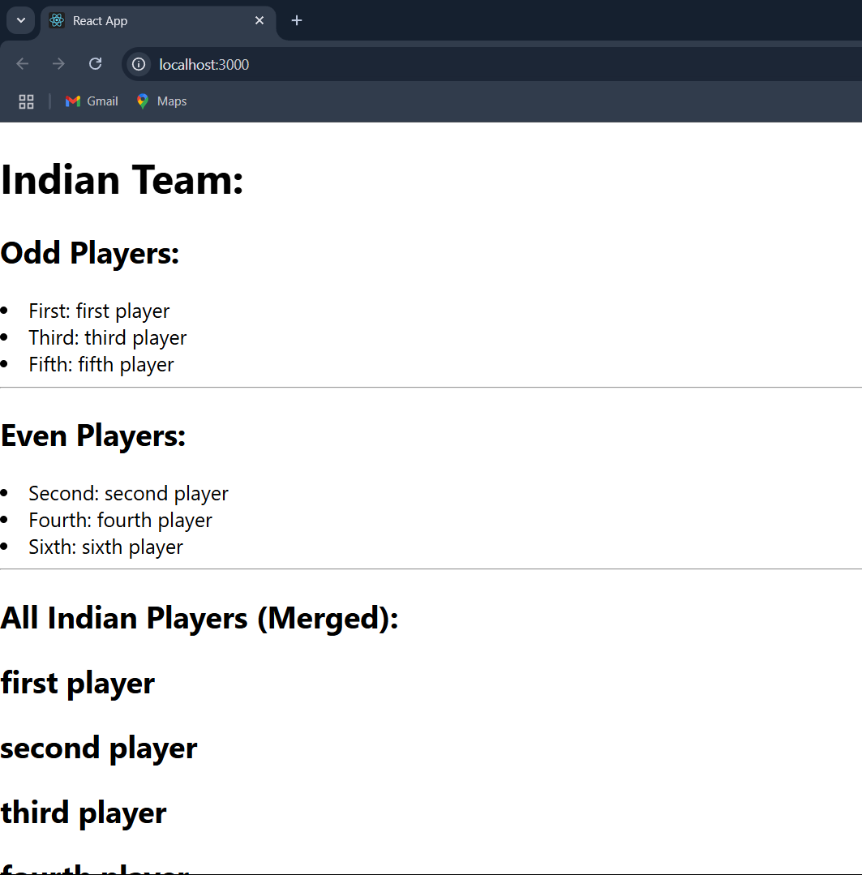

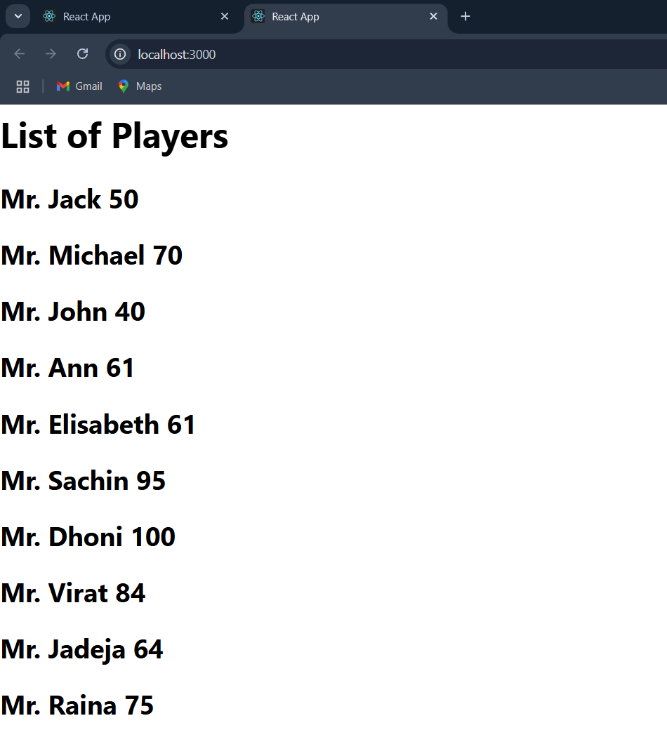When flag=== false

